MCA MINI PROJECT REPORT
Console Record-Management Application
Student Record Management System
Assignment 1
Submitted as part of the MCA curriculum
Language / Tools: Python 3, JSON (standard library)

1. Introduction
This project implements a Console-based Record-Management Application in Python. The application is designed as a Student Record Management System that allows a user to add, view, search, update, and delete student records through a text-based menu. The primary goal of the project is to demonstrate, within a single working program, the core Python concepts covered in the syllabus: data types and variables, conditional statements, loops, functions, exception handling, file input/output, and menu-driven program design.
The application stores its data permanently using a JSON file, so records entered by the user remain available even after the program is closed and reopened. The project intentionally avoids advanced or unnecessary concepts such as classes, decorators, or external databases, keeping the implementation simple, readable, and fully explainable by the student who built it.

2. Objectives
- To build a working, menu-driven console application in Python.
- To design and use an appropriate data structure for managing multiple records.
- To implement Create, Read, Update, and Delete (CRUD) style operations on records.
- To persist data between program runs using File I/O and the JSON format.
- To handle invalid input and runtime errors gracefully using exception handling.
- To organise the program into small, well-named functions rather than one large block of code.

3. Problem Statement and Theme
The chosen theme is a Student Record Management System, a simple and realistic scenario suitable for an MCA-level assignment. Each record represents one student and stores the following fields:
Field | Data Type | Example | Reason for Type
Student ID | string (str) | "101" | Treated as text, not a number, since it is an identifier and not used in calculations.
Name | string (str) | "Riya Sharma" | Textual data.
Age | integer (int) | 21 | A numeric value that may be validated (e.g., must be positive).
Course | string (str) | "MCA" | Textual data.
Email | string (str) | "riya@example.com" | Textual data.
Phone | string (str) | "9876543210" | Stored as text so leading digits are never lost.

Student ID is treated as the unique key of each record. Every search, update, and delete operation locates a record by matching this field, and the application prevents two records from sharing the same ID.

4. Data Structure Design
Each individual student is represented using a Python dictionary, since a dictionary allows each value to be accessed by a meaningful key (for example, student["name"]) rather than by position. This makes the code self-explanatory and reduces the chance of accessing the wrong field.
The complete set of student records is stored in a Python list of dictionaries:
[
{"id": "101", "name": "Riya Sharma", "age": 21,
"course": "MCA", "email": "riya@example.com", "phone": "9876543210"},
{"id": "102", "name": "Aman Verma", "age": 22,
"course": "MCA", "email": "aman@example.com", "phone": "9123456780"}
]
This structure was chosen because a list allows records to be freely added, removed, and iterated over, while a dictionary keeps each record's fields labeled and readable. It also maps directly onto JSON's own structure (an array of objects), which greatly simplifies File I/O.

5. System Design

5.1 Program Flow
Start
|
v
Load records from students.json (if it exists)
|
v
+---------------------------+
| Display menu | <----------------+
+---------------------------+ |
| |
v |
Get and validate user's choice |
| |
v |
Call matching function |
(Add / View / Search / Update / Delete) |
| |
v |
Save records to file (if data changed) ---------+
|
v (choice = Exit)
End

5.2 Menu Options
1. Add Record
2. View Records
3. Search Record
4. Update Record
5. Delete Record
6. Exit

5.3 Functions and Their Purpose
Function | Purpose
load_records() | Reads students.json at startup and returns the list of records. Returns an empty list if the file is missing or contains invalid data.
save_records(records) | Writes the current list of records back to students.json.
find_student_by_id(records, id) | Shared helper that searches the list for a record with a matching ID. Used by search, update, and delete so the same logic is not repeated three times.
display_menu() | Prints the numbered menu of available operations.
add_record(records) | Collects and validates new student details, checks for duplicate IDs, and appends the new record.
view_records(records) | Prints every stored record in a readable format.
search_record(records) | Prompts for a Student ID and displays the matching record, or reports that none was found.
update_record(records) | Prompts for a Student ID, lets the user choose one field, validates the new value, and updates it.
delete_record(records) | Prompts for a Student ID, confirms with the user, and removes the matching record.
main() | Loads data, runs the menu loop, and routes each user choice to the correct function.

6. File Handling (File I/O)
The application uses JSON (JavaScript Object Notation) as its storage format via Python's built-in json module. JSON was chosen because it maps naturally onto Python's list-of-dictionaries structure, is human-readable, and can be converted to and from Python objects using a single function call (json.load and json.dump).
Situation | Behaviour
Program starts, file exists | Records are loaded into memory using json.load().
Program starts, file does not exist | A FileNotFoundError is caught and the program starts with an empty list.
File exists but contains invalid/corrupted JSON | A json.JSONDecodeError is caught, a warning is shown, and the program starts with an empty list rather than crashing.
A record is added, updated, or deleted | The full, updated list is written back to students.json using json.dump(), overwriting the previous contents.

7. Exception Handling
Exception handling is used throughout the program to prevent crashes from predictable user or file errors. Specific exception types are caught wherever possible, rather than using a broad except: clause, so that only the expected error is handled and unexpected bugs are not silently hidden.
Exception Type | When It Occurs | How It Is Handled
ValueError | User types non-numeric text where a number (menu choice or age) is expected. | Caught, a clear message is shown, and the user is asked again.
FileNotFoundError | students.json does not exist yet (first run). | Caught inside load_records(); the program starts with an empty list.
json.JSONDecodeError | students.json exists but its contents are not valid JSON. | Caught inside load_records(); a warning is shown and the list starts empty.
OSError | The file cannot be read or written (e.g., permission issues). | Caught in load_records() / save_records() with a descriptive message.

8. Validation Rules
- Student ID must not be empty, and must be unique across all records.
- Name and Email must not be empty.
- Age must be a valid whole number greater than zero.
- Update and Delete operations only proceed if the entered Student ID exists.
- Delete requires an explicit "y" confirmation before removing a record.

9. Sample Program Output
===== Student Record Management System =====
1. Add Record
2. View Records
3. Search Record
4. Update Record
5. Delete Record
6. Exit
==============================================
Enter your choice: 1
--- Add New Student Record ---
Enter Student ID: 101
Enter Name: Riya Sharma
Enter Age: 21
Enter Course: MCA
Enter Email: riya@example.com
Enter Phone: 9876543210
Student 'Riya Sharma' added successfully.

10. Testing
The application was tested against the following cases:
Test Case | Input | Expected Result
Add valid record | Valid details | Record added and saved
Duplicate ID | Existing ID | Error message, record not added
Invalid age | "abc" | Error message, record not added
Search existing ID | Existing ID | Record displayed
Search invalid ID | Non-existing ID | "Not found" message
Update record | Existing ID + valid new value | Field updated and saved
Delete record | Existing ID + "y" confirmation | Record removed and saved
Missing file | No students.json present | Program starts with an empty list, no crash
Exit | 6 | Program closes cleanly

11. Mapping to Assignment Requirements
Requirement | Where Demonstrated
Data Types and Variables | id, name, phone, course, email as str; age as int; records as a list of dict.
Conditional Statements | if/elif/else chains routing menu choices; validation checks in add/update/delete.
Loops | while True: for the main menu; for loops inside view_records() and find_student_by_id().
Functions | Ten separate functions, each handling one responsibility (see Section 5.3).
Exception Handling | try/except around numeric input and file operations (see Section 7).
File I/O | load_records() and save_records() using the json module (see Section 6).
Menu-driven Design | display_menu() plus the while loop in main() that repeatedly presents options.

12. Core Python Concepts Demonstrated
This section walks through each core concept required by the assignment individually, with an explanation followed by an actual console screenshot from running the program.

12.1 Data Types and Variables
The program uses string (str) variables for Student ID, Name, Course, Email, and Phone, and an integer (int) variable for Age. These are collected through add_record() and stored as a dictionary, shown below being filled in during an Add Record session.
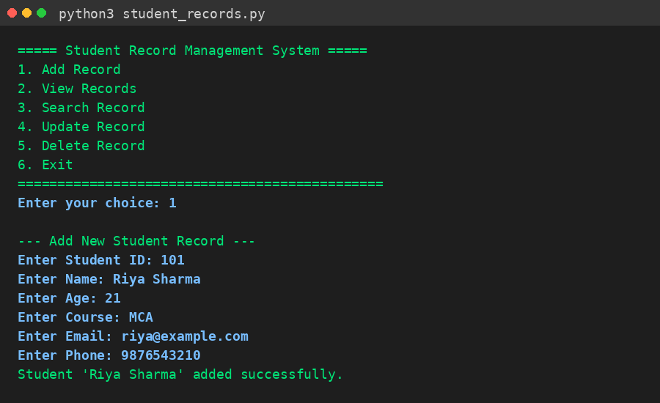
Figure 1: Add Record - demonstrates str and int variables being collected and stored.

12.2 Conditional Statements and Loops
A for loop in view_records() iterates through the list of student dictionaries and prints each one; if/else checks whether the list is empty before looping. The screenshot below shows View Records output, produced entirely by looping over the stored list.
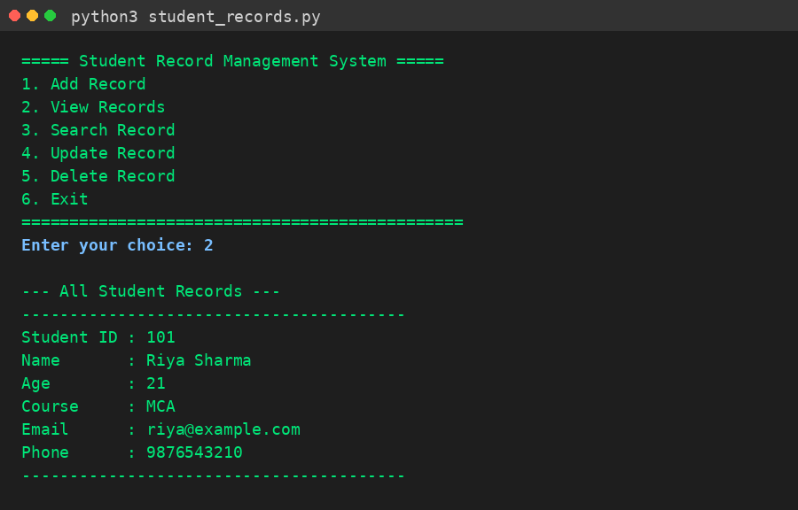
Figure 2: View Records - a for loop iterating over the list of dictionaries.

12.3 Functions
Every operation is implemented as its own function. search_record() calls the shared helper function find_student_by_id(), shown here first failing to find a non-existent ID and then successfully returning a match - the same helper function is reused by update_record() and delete_record().
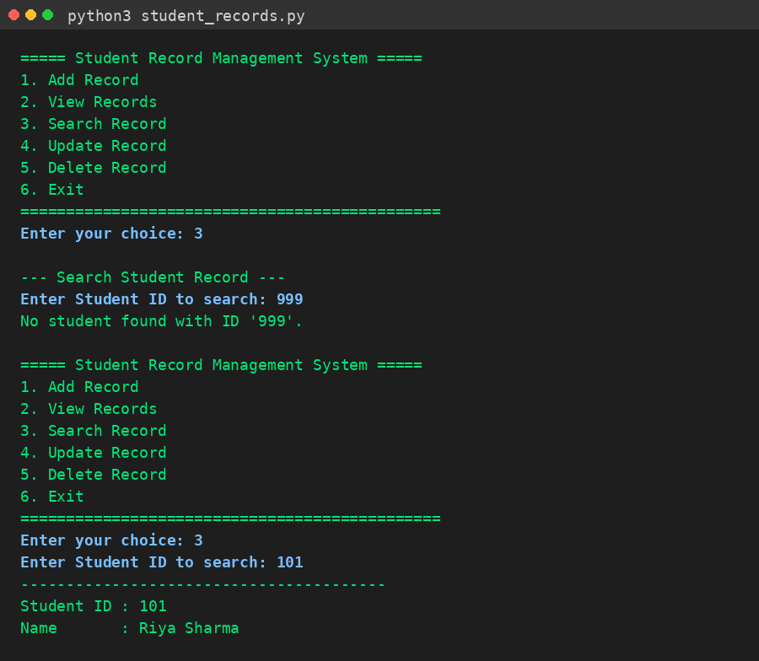
Figure 3: Search Record - demonstrates find_student_by_id() being called with two different results.

12.4 Exception Handling
try/except blocks catch invalid, non-numeric age input (ValueError) inside add_record(), and a duplicate-ID check prevents two records from sharing the same Student ID. Neither case crashes the program - both are handled gracefully with a clear message.
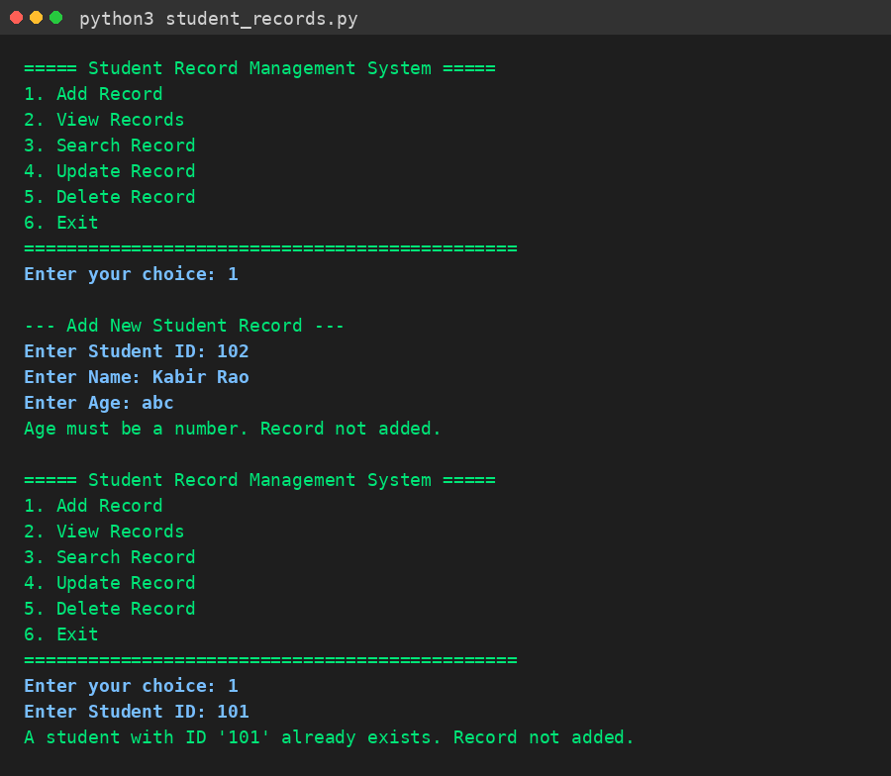
Figure 4: Invalid age input and a duplicate Student ID, both handled without crashing.

12.5 File I/O
save_records() writes the full list of records to students.json using json.dump(), and load_records() reads it back using json.load() the next time the program starts. The screenshot below shows the actual contents of students.json after a record was added - confirming the data was written to disk, not just held in memory.
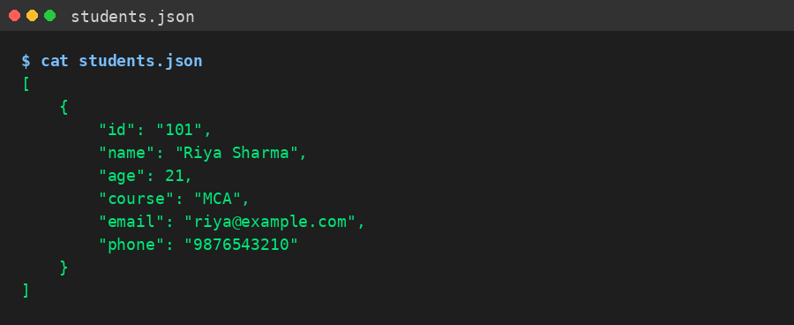
Figure 5: Contents of students.json on disk after saving - confirms persistence across runs.

12.6 Menu-driven Console Application Design
display_menu() prints the numbered options, and a while True loop in main() keeps showing this menu until the user chooses Exit (6). The screenshot shows an invalid menu choice (9) being rejected before a valid Exit is accepted.
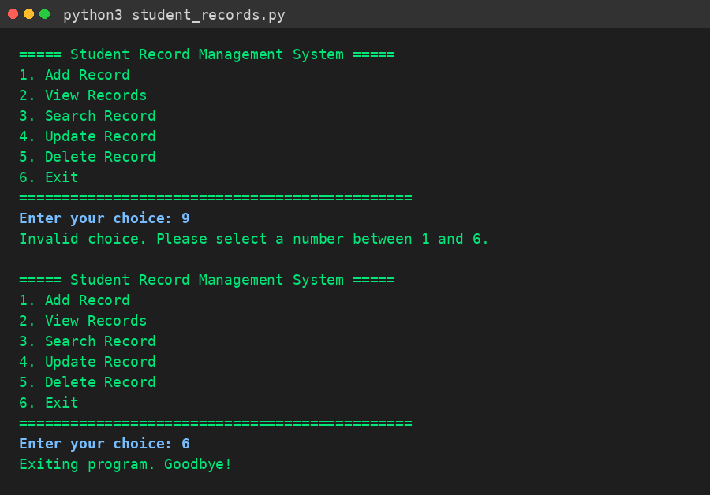
Figure 6: The main menu loop - rejecting an invalid choice, then exiting cleanly.

13. Conclusion
The Student Record Management System successfully satisfies all the requirements of the assignment. It provides a working menu-driven console interface, uses an appropriate data structure (a list of dictionaries), is organised into small reusable functions, handles invalid input and file errors gracefully, and persists data across program runs using a JSON file. The project remains intentionally simple, avoiding unnecessary advanced concepts, while still fully demonstrating every core Python topic it was designed to cover.

